
Focus Group Activities

Activities are a great way of focusing thoughts and generating reflection and conversation about both general feelings about a residential and specific learning. You can find some examples of activities we used during the action research phase of Learning Away in in the resources section of the toolkit. We have separated it into two sections, one for Key Stage 2 pupil activities and another for Secondary student activities. Special school staff can choose which activities will work with their students.

These are just examples; you may have existing resources in school or ideas of your own that you can use with very effective results.

Where possible, we have illustrated each section with completed examples but clean copies of each example, and others you may want to use, can also be downloaded from the toolkit’s Resources Library.

Activities for Primary Pupils

1. Gingerbread person: general reflections
We used these as an activity to gain an overall picture of:

- Likes (in the shopping basket) and dislikes (in the bin)
- /10 overall mark for the residential (in the head area)
- Free choice of words to describe the residential (anywhere in the body)
- /10 confidence mark before and after the residential (left and right feet)
- /10 mark for how proud they felt about themselves (in the heart).

We completed tasks 1-3 at the beginning of the focus group; the answers from this task enabled us to start to unpick some of the reasons for their answers and led well into more specific questions. Tasks 4 and 5 were done later in the group: task 4 during the section on confidence, resilience and wellbeing and task 5 at the end. Even Year 6 enjoyed doing this, despite us thinking at the beginning of the focus group process that it would only be something that younger pupils would enjoy.

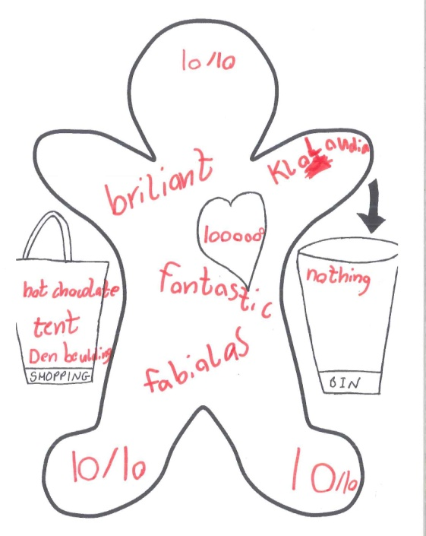
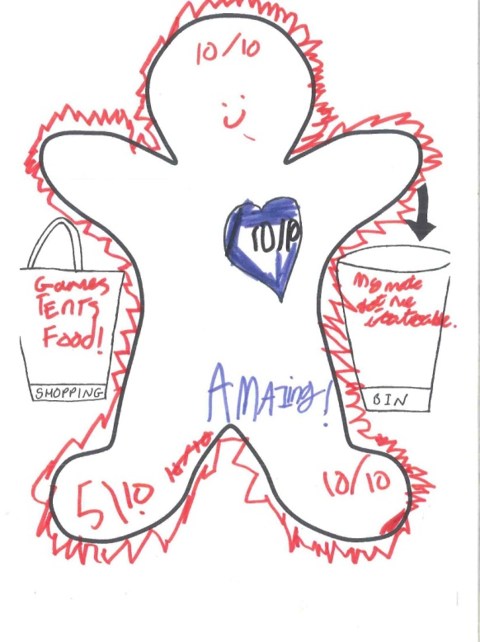

2. Free drawing: what sticks in your mind most about the residential?

This is another possible starting point that you can use to explore particular areas of the residential in more detail. Here is an example that shows something about both the activities on the residential and the weather (great for asking some questions about resilience)!

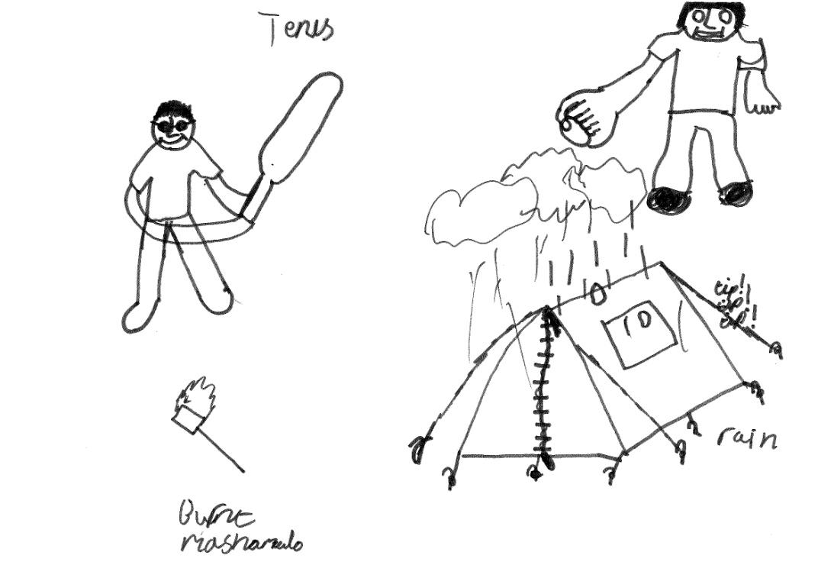

3. Thought and speech bubbles
These were useful to capture thoughts about specific areas of the residential, for example activities or changes the pupils thought had happened to them as a result of the residential.

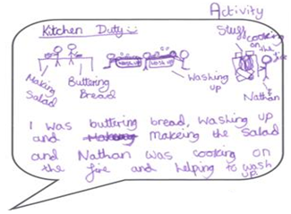

4. Drawing and/or text about a particular change, skill or attitude
Doing this activity can bring some rich data and some useful quotes, as the two examples below show well. Again, doing an activity like this is a good starting point that will enable you to probe more about what helped in making the change, skill or attitude happen.

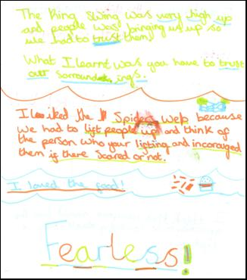

Activities for Secondary Students

1. Thought and speech bubbles
We used these to ask students to:

- Highlight things about the residential that had been memorable for or important to them

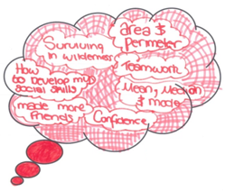

- Think about specific changes that had come about as a result of the residential – in the first examples below we asked them to think about confidence specifically, and in the second example we asked them to think more generally about what changes had occurred.

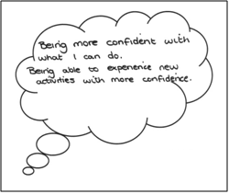
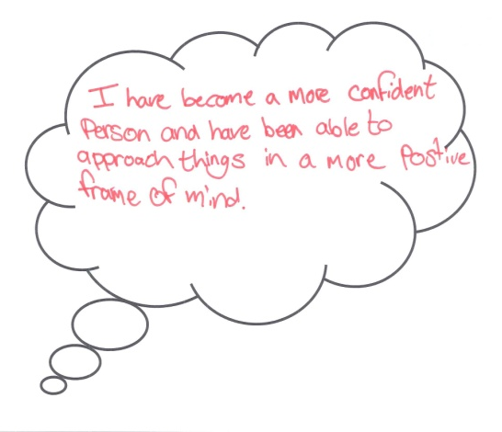
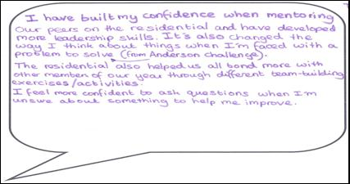

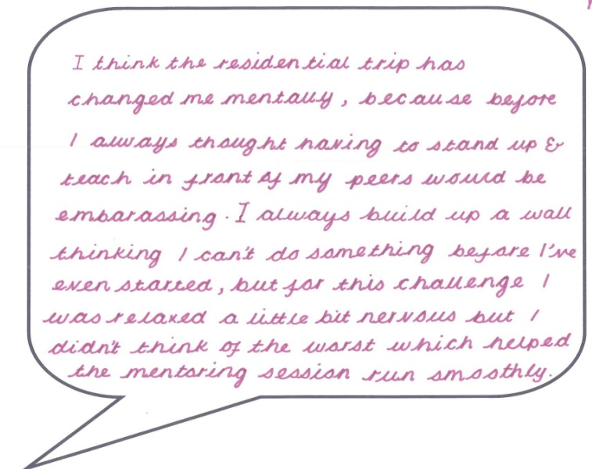

2. Thermo-evaluators
We found these most useful when asking students to record changes they felt had happened in subject areas. The questions we asked were ‘How do you think you were doing in [subject] before the residential?’ and ‘How do you think you are doing in this subject now?’ Depending on the residential, we asked them to think about several subjects or just one. As you can see from the left hand example, we sometimes also asked them to record in writing what had helped with the change; this question was always asked verbally.

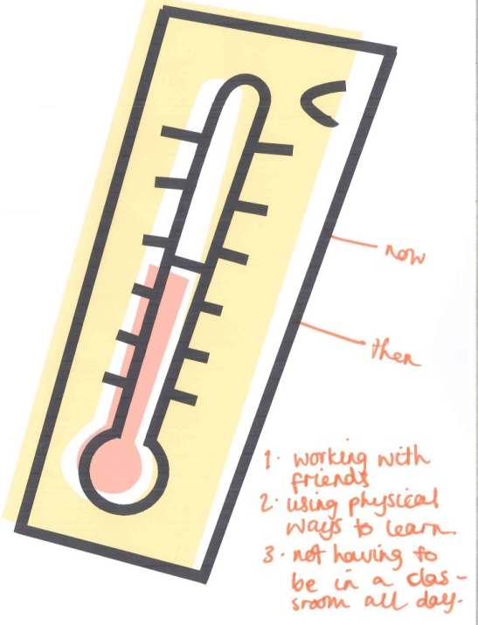
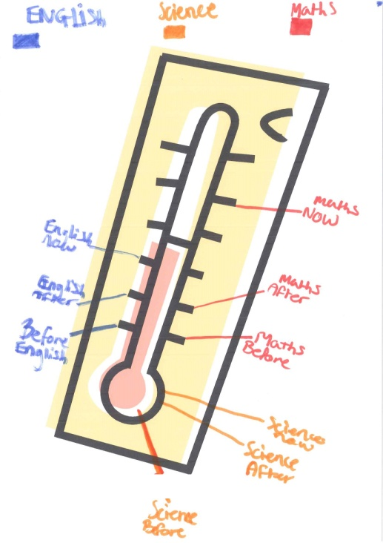

3. Timeline graphs
These are a slightly more sophisticated way of collecting similar data to the thermo-evaluators, and may give you more of an idea about the trajectory of change before, during and after the residential, which you can then ask further questions about to find out more detail. We also, as the example below showed, asked students to record their change in confidence and motivation as well as for subject areas.

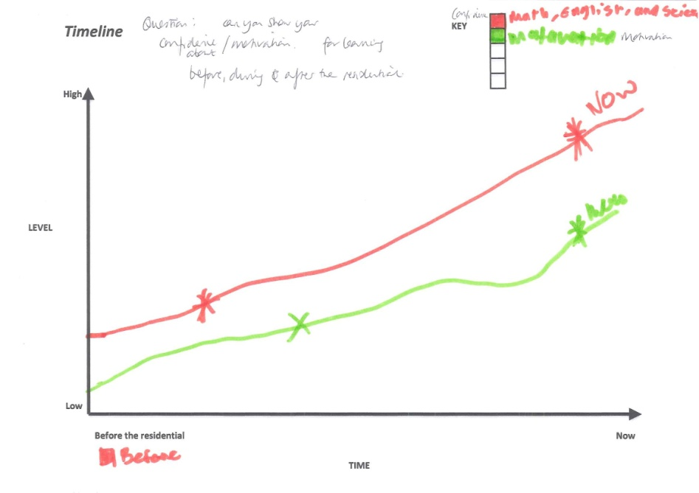

4. Targets

This was helpful to interrogate specific subject areas, using the following questions:
- Which subject are you thinking about? Write this at the top of the paper
- Which activity particularly helped you with this subject? Write this in the centre of the target.
- What specific parts of the subject ie. knowledge, skills, understanding, did this activity help with? Write these in the next target circle moving outwards.
- What did you do that helped you learn this? Write these in the next target circle.
- Who helped you learn this? Write about this in the outermost circle.

We then asked students to talk the group through their targets and asked probe questions to elicit more detailed information.

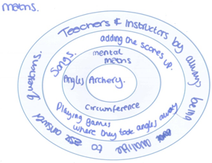

5. Quartered speech bubbles
This was another useful way of drawing out students’ thoughts about changes to their learning and, again, using this as a starting point for a more in-depth conversation. We used a speech bubble that the students separated into four quarters. We asked them to record their thoughts in each quarter as follows:

- Top left: Tell us about one of the main things that you learnt on the residential.
- Top right: What skills did you learn from this?
- Bottom left: Who helped you with your learning?
- Bottom right: How did you learn on the residential?

