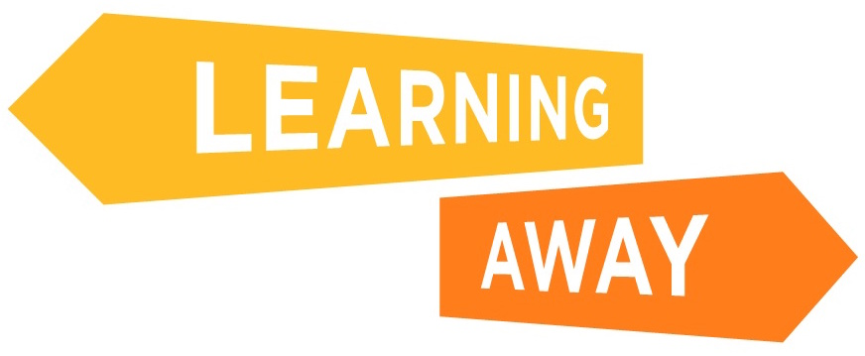
Key Stage 2 Surveys – Longer Term Follow-up Questions

ID number (given by your teacher): ____________________

1. Attainment Questions

Tick the answers that match what you think!

 | Yes | Not sure | No
Because of the trip, I am better at my school work
Because of the trip, I have done better in my tests at school
Because of the trip, I know how to do better work at school
Because of the trip, I am better at numeracy
Because of the trip, I am better at reading and writing

Have you been able to use what you learnt on the trip back in school?

Yes | Not sure | No

Tell us how you have been able to use what you learnt on the trip back in school

2. Knowledge and Understanding Questions

Tick the answers that match what you think!

 | Yes | Not sure | No
Because of the trip, my learning in school is more interesting
Since going on the trip, when I am given a task, even if I don’t know the answer straight away,
I feel I will be more able to work it out
My teachers and my lessons on the trip helped me learn
Because of the trip, I enjoy my school work more

3. Skills Development Questions

Tick the answers that match what you think!

 | Yes | Not sure | No
Because of the trip, I am better at listening to my teacher
Because of the trip, I am better at solving problems in my school work
Because of the trip, I join in with discussions in class more
Because of the trip, I am happier to talk in front of my class at school
Because of the trip, I am better at working in a group at school

4. Learner Engagement Questions

Tick the answers that match what you think!

 | Yes | Not sure | No
Because of the trip, I find my lessons more interesting
Because of the trip, I am happier when I am learning
Because of the trip, I am less likely to give up when school work is difficult
Because of the trip, I get less bored in class
Because of the trip, my attendance at school is better
Because of the trip, I am on time for school for often
Because of the trip, my behaviour at school is better
Because of the trip, I like school more
Because of the trip, I think learning is more important than I did before

5. Relationships Questions

Tick the answers that match what you think!

 | Yes | Not sure | No
Because of the trip, I know my teachers better
Because of the trip, my teachers know me better
Because of the trip, I get on better with the other children in my class

6. KS2 to KS3 Transition Questions

Tick the answers that match what you think!

 | Yes | Not sure | No
Because of the trip, I find it easier to make new friends
Because of the trip, I like trying new things
Because of the trip, I am excited about changing class or school

What worries you most about going to secondary school? (Tick up to three)

Finding my way round or getting lost |  | Coming to school on my own |  | Any others (please say what these are)
Not knowing anyone |  | Getting detention
Making new friends |  | Finding the work too hard
Not being with my old friends |  | Having new teachers
Being bullied |  | Having stricter teachers
Going to lunch on my own |  | Nothing worries me about going to secondary school

Do you feel less worried about next year because of going on the trip?

Yes | No | Don’t know

How did the trip help you feel better about next year?

7. Leadership, Co-design and Facilitation Questions

Since going on the trip, have you started doing any of the following at school that you didn’t do before?

I lead a club |  | Any others (please say what these are)
I am a lunch monitor
I am an eco school leader
I captain a sports team
I am on the school council
I do none of these
Tick the answers that match what you think!

 | Yes | Not sure | No
The trip has made me realise I can be a good example to other pupils
The trip has made me realise I can help people with their learning

Since the trip, have you got more involved in helping to decide what you are going to learn or how you learn it in school?

Yes
Not sure
No

How have you got more involved in helping decide what you learn or how you learn in school?

8. Cohesion Questions

Tick the answers that match what you think!

 | Yes | Not sure | No
The trip has helped me to feel part of my school
Everyone in my school gets on well together
The trip helped me realise I could get on with people from my school, other classes or other schools
Because of the trip, when I get into an argument with someone, I am more able to sort it out by talking to them

9. Resilience, Confidence and Wellbeing Questions
Tick the answers that match what you think!

 | Yes | Not sure | No
Because of the things I learnt on the trip, I don’t give up when I find things difficult at school
Because of the trip, I worry less about my school work
Because of the trip, I ask for help if I have problems or worries at school
Because of the trip, I try things I wouldn’t have done before
Because of the trip, I now know more about how to work in a team
Because of the trip, I now know how to do things on my own and work independently
Because of the trip, I know more about how to work in a group to solve problems
Because of the trip, I know more about how to listen to other people
The trip has made me realise I have a lot to be proud of
The trip has made me realise there are lots of different things I could do when I grow up
I am proud of what I achieved on the trip

10. Now for some questions about your residential/trip

How have you been able to use what you learnt on the trip back in school?

What is your best memory of the trip?

What would you say to other children who are unsure about going on a trip?

