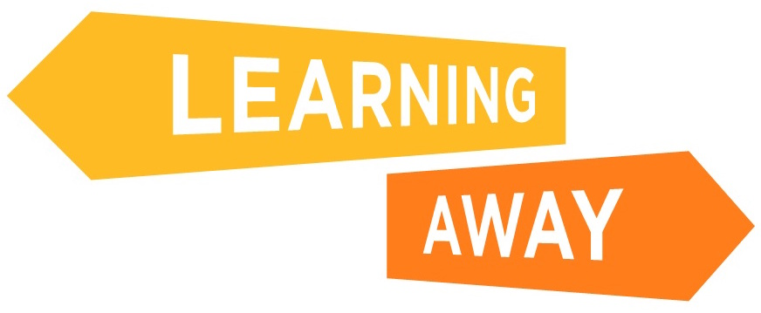
Key Stage 3 and 4 Surveys – Post-residential Questions

ID number (given by your teacher): ____________________

1. Attainment Questions

Tick the answers that match what you think!

 | Strongly agree | Agree | Not sure | Disagree | Strongly Disagree
I think I am doing better in this subject than I did before I went on the residential
What I learnt on the residential has helped me do better in my exams/tests in this subject
The activities on the residential have helped me to better understand this subject
Because of the residential, when I am given a problem in this subject, I am now more able to solve the problem
The way I was taught and helped to learn on the residential has helped me do better in this subject

Thinking about your answers to the questions above, have you been able to use what you learnt on the residential back in school to help you do better in this subject?

Yes | No | Not sure

How have you been able to use what you learnt on the residential back in school to do better in this subject? (Please reply in the box below)

2. Knowledge and Understanding Questions

Tick the answers that match what you think!

 | Strongly agree | Agree | Not sure | Disagree | Strongly Disagree
Because of the residential, I think I know a lot more about this subject
Because of the residential I have a better understanding of what I am trying to learn in this subject
The lessons and the way I was taught on the residential have helped me to learn
Since going on the residential, when I am given a task, even if I don’t know the answer straight away, I feel I will be more able to work it out
Since going on the residential, I think this subject is more interesting and important to me
Because of the residential, I enjoy this subject more
As a result of the residential I have learnt new skills in this subject
As a result of the residential, I feel I will make better progress in this subject
Because of the residential, I have a better understanding of what I am good at, and not so good at, at school

Thinking about your answers to the questions above, have you been able to use what you learnt on the residential back in school to help you better understand this subject? (Please reply in the box below)

Yes | Not sure | No

3. Skills Development Questions

Tick the answers that match what you think!

 | Strongly agree | Agree | Not sure | Disagree | Strongly Disagree
Because of the residential, I feel more able to join in discussions in class
Because of the residential, I am more confident in explaining things to other people at school
Because of the residential, I am more comfortable talking in front of a group in class
Because of the residential, I am better at listening to other people at school
Because of the residential, I am better at solving problems in my school work
Because of the residential, I am more confident working in a group at school
Because of the residential, I have learnt new skills in this subject
Because of the residential, I have a better understanding of what I am good at, and not so good at, at school

Have you been able to use the new skills you learnt on the residential back in school?

Yes
Not sure
No
I did not learn new skills on the residential

Have you been able to use the different ways of learning on the residential back in school?

Yes
Not sure
No
I did not learn in different ways on the residential

4. Learner Engagement Questions

Tick the answers that match what you think!

 | Strongly agree | Agree | Not sure | Disagree | Strongly Disagree
Because of the residential, I feel more strongly motivated to learn / I want to learn more
Because of the residential, I feel that my school work is more important to me and my future
Because of the residential, I find lessons more interesting
Because of the residential, I am less likely to give up when school work is difficult
Because of the residential, I get less bored in lessons
Because of the residential, I like school more
Because of the residential, I my attendance at school is better
Because of the residential, I try harder to be on time for lessons
Because of the residential, I my behaviour at school is better

Thinking about your answers to the questions above, has the residential helped you to change as a person?

Yes | Not sure | No

5. Relationships Questions

Tick the answers that match what you think!

 | Strongly agree | Agree | Not sure | Disagree | Strongly Disagree
Because of the residential, I get on better with my teachers
Because of the residential, my teachers know me better
Because of the residential, my teachers have a better understanding of how I like to learn
Because of the residential I get on better with the other pupils in my class
Because of the residential, I am happier to work with all my classmates in my lessons
Because of the residential, I got to know people I didn’t know before who I am still in touch with
As a result of going on the residential, I am more able to talk about how I get on with other people
How I get on with my teachers, other pupils and/or people outside school has changed since going on the residential

Has the residential changed how you get on with your teachers or other staff in school?

Yes | Not sure | No

How did the residential change how you get on with your teachers or other staff in school? (Please reply in the box below)

Has the residential changed how you get on with other pupils?

Yes | Not sure | No

How did the residential change how you get on with other pupils? (Please reply in the box below)

Has the residential changed how you get on with other people outside of school?

Yes | Not sure | No

How did the residential change how you get on with other people outside of school? (Please reply in the box below)

6. Transition Questions

Tick the answers that match what you think!

 | Strongly agree | Agree | Not sure | Disagree | Strongly Disagree
Because of the residential, I am better at coping with new situations
Because of the residential, I find it easier to make new friends
Because of the residential, I am happier working with people who are not my close friends
Because of the residential, I like trying new things
Because of the residential, I am more excited about this new year at school

What worries you most about this year at school? (Please reply in the box below)

Do you feel less worried about this year at school as a result of going on the residential?

Yes | Not sure | No

How did the residential help you feel better about this year? (Please reply in the box below)

7. Leadership, Co-design and Facilitation Questions

Since going on the residential, have you taken on any of the following roles at school that you didn’t do before?

I am a prefect/ambassador |  | I do none of these
I am a class representative |  | Any others (please say what these are)
I am a sports leader
I lead a club
I am a lunch monitor
I am an eco school leader
I captain a sports team
I am on the school council

Tick the answers that match what you think!

 | Strongly agree | Agree | Not sure | Disagree | Strongly Disagree
Because of the residential, I have got more involved in helping to decide what we are going to learn or how we learn it in school
Because of the residential, I find that I am more likely to suggest ways of doing things
The residential has made me realise anyone can be a leader if they want to
The residential has made me realise I can be a role model for other pupils
The residential has made me realise I can help people with their learning
I learn more if I am involved in the planning of learning for the residential
Since going on the residential, I have been able to lead activities back in school

Since going on the residential, what leadership opportunities have you been involved in back at school? (Please reply in the box below)

Since going on the residential, what opportunities have you had to be involved in decision-making back in school, for example in your learning or other school activities? (Please reply in the box below)

8. Cohesion Questions

Tick the answers that match what you think!

 | Strongly agree | Agree | Not sure | Disagree | Strongly Disagree
Because of the residential, I am more aware that I can learn from the experiences of other people
People from different backgrounds get on well together in my school
The residential has helped me to feel part of my school community
The residential has helped me feel part of my local community out of school
Because of the residential, when I get into an argument with someone, I think I will be more able to sort it out by talking to them
The residential helped me realise I could get on with people from my school, other classes or other schools

Thinking about your answers to the questions above, how do you think the residential helped you? (Please reply in the box below)

9. Resilience, Confidence and Wellbeing Questions
Tick the answers that match what you think!

 | Strongly agree | Agree | Not sure | Disagree | Strongly Disagree
I am less likely to give up when I find things difficult at school because of the things I learnt on the residential
I worry less about my schoolwork because of the residential
Because of the residential, I am more likely to ask for help if I have problems or worries at school
I am a more confident person because of the experiences I have had on the residential
Because of the residential, I am more positive about my future
The residential has made me realise I have a lot to be proud of
The residential has made me realise there are lots of different things I could do when I grow up
I am proud of what I achieved on the residential
I learned things about myself I didn’t know before
Because of the residential, I feel more confident to try things I wouldn’t have done before

Thinking about your answers to the questions above, has the residential helped you to change as a person?

Yes | Not sure | No

How do you think the residential helped you change as a person? (Please reply in the box below)

10. Now for some questions about your residential

What is your best memory of the residential? (Please reply in the box below)

What had the biggest impact on you, for example in terms of your learning, or you as a person? (Please reply in the box below)

What would you say to other young people who are unsure about going on a residential? (Please reply in the box below)

