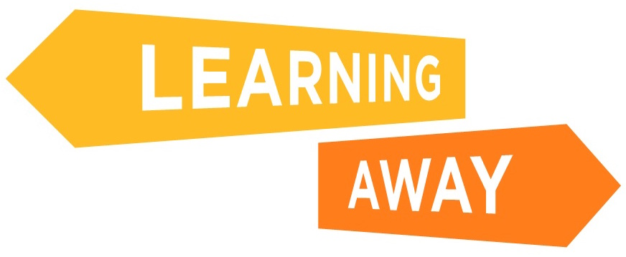
Key Stage 3 and 4 Surveys – Post-residential Questions

ID number (given by your teacher): ____________________

1. Attainment Questions

Tick the answers that match what you think!

 | Strongly agree | Agree | Not sure | Disagree | Strongly Disagree
I think I will now do better in this subject than I did before I went on the residential
Because of the residential, I am more confident that I will do well in my exams/tests in this subject
The activities on the residential helped me to better understand this subject
Because of the residential, when I am given a problem in this subject, I feel I will be more able to solve the problem
The way I was taught and helped to learn on the residential will help me do better in this subject

Thinking about your answers to the questions above, how did the residential help you to learn and better understand this subject?
(Please reply in the box below)

2. Knowledge and Understanding Questions

Tick the answers that match what you think!

 | Strongly agree | Agree | Not sure | Disagree | Strongly Disagree
Because of the residential, I think I know a lot more about this subject
Because of the residential I have a better understanding of what I am trying to learn in this subject
The lessons and the way I was taught on the residential have helped me to learn
Since going on the residential, when I am given a task, even if I don’t know the answer straight away, I feel I will be more able to work it out
Since going on the residential, I think this subject is more interesting and important to me
Because of the residential, I enjoy this subject more
As a result of the residential I have learnt new skills in this subject
As a result of the residential, I feel I will make better progress in this subject
Because of the residential, I have a better understanding of what I am good at, and not so good at, at school

Thinking about your answers to the questions above, how did the residential help you with this subject? (Please reply in the box below)

3. Skills Development Questions

Tick the answers that match what you think!

 | Strongly agree | Agree | Not sure | Disagree | Strongly Disagree
Because of the residential, I feel more able to join in discussions in class
Because of the residential, I am more confident in explaining things to other people at school
Because of the residential, I am more comfortable talking in front of a group in class
Because of the residential, I am better at listening to other people at school
Because of the residential, I am better at solving problems in my school work
Because of the residential, I am more confident working in a group at school
Because of the residential, I have learnt new skills in this subject
Because of the residential, I have a better understanding of what I am good at, and not so good at, at school

What activities on the residential helped you learn new skills? (Please reply in the box below)

Thinking about your answers to the questions above, how do you think the residential helped you learn new skills? (Please reply in the box below)

How were the ways of learning on the residential different to learning in school? (Please reply in the box below)

Do you like learning in this way?

Yes
No
I don’t know
The ways of learning on the residential were not different to learning in school

Why do you like learning in this way? (Please reply in the box below)

Why don’t you like learning in this way? (Please reply in the box below)

4. Learner Engagement Questions

Tick the answers that match what you think!

 | Strongly agree | Agree | Not sure | Disagree | Strongly Disagree
Because of the residential, I feel more strongly motivated to learn / I want to learn more
Because of the residential, I feel that my school work is more important to me and my future
Because of the residential, I think I will find lessons more interesting
Because of the residential, I am less likely to give up when school work is difficult
Because of the residential, I think I will not be as bored in class
Because of the residential, I like school more
Because of the residential, I think my attendance at school will be better
Because of the residential, I will try harder to be on time for lessons
Because of the residential, I think my behaviour at school will be better

Thinking about your answers to the questions above, how has the residential helped you? (Please reply in the box below)

5. Relationships Questions

Tick the answers that match what you think!

 | Strongly agree | Agree | Not sure | Disagree | Strongly Disagree
Because of the residential, I get on better with my teachers
Because of the residential, my teachers know me better
Because of the residential, my teachers have a better understanding of how I like to learn
Because of the residential I get on better with the other pupils in my class
Because of the residential, I am happier to work with all my classmates in my lessons
Because of the residential, I got to know people I didn’t know before
As a result of going on the residential, I feel better able to talk about my relationships with other people

In what ways have your relationships with teachers, other pupils and people outside school changed as a result of the residential?
(Please reply in the box below)

Thinking about your answers to the questions above, how do you think the residential helped improve your relationships with other people?
(Please reply in the box below)

6. Transition Questions

Tick the answers that match what you think!

 | Strongly agree | Agree | Not sure | Disagree | Strongly Disagree
Because of the residential, I am better at coping with new situations
Because of the residential, I find it easier to make new friends
Because of the residential, I am happier working with people who are not my close friends
Because of the residential, I like trying new things
Because of the residential, I am more excited about changing class/school next year

What worries you most about next year? (Please reply in the box below)

Do you feel less worried about next year because of going on the residential?

Yes | No | Don’t know

How did the residential help you feel better about next year? (Please reply in the box below)

7. Leadership, Co-design and Facilitation Questions

Do you do any of the following at school?

I am a prefect/ambassador |  | I do none of these
I am a class representative |  | Any others (please say what these are)
I am a sports leader
I lead a club
I am a lunch monitor
I am an eco school leader
I captain a sports team
I am on the school council

Tick the answers that match what you think!

 | Strongly agree | Agree | Not sure | Disagree | Strongly Disagree
Because of the residential, I would like to get more involved in helping to decide what we are going to learn or how we learn it in school
Because of the residential, I find that I am more likely to suggest ways of doing things
The residential has made me realise anyone can be a leader if they want to
The residential has made me realise I can be a role model for other pupils
The residential has made me realise I can help people with their learning
I learn more if I am involved in the planning of learning for the residential
On the residential, I got the opportunities to be involved in leading the activities that I thought I would
On the residential, I enjoyed the opportunity to lead activities

Thinking about your answers to the questions above, how do you think the residential helped you? (Please reply in the box below)

8. Cohesion Questions

Tick the answers that match what you think!

 | Strongly agree | Agree | Not sure | Disagree | Strongly Disagree
The residential has made me realise that it’s OK for people to have different views
Because of the residential, I more aware that I can learn from the experiences of other people
The residential has helped me to feel part of my school community
The residential has helped me feel part of my local community out of school
The residential helped me realise I could get on with pupils from other schools

Tick the answers that match what you think!

 | Almost always | Often | Sometimes | Rarely | Never
Because of the residential, when I get into an argument with someone, I think I will be more able to find a solution
People from different backgrounds get on well together in my school

Thinking about your answers to the questions above, how do you think the residential helped you? (Please reply in the box below)

9. Resilience, Confidence and Wellbeing Questions
Tick the answers that match what you think!

 | Strongly agree | Agree | Not sure | Disagree | Strongly Disagree
I am less likely to give up when I find things difficult at school because of the things I learnt on the residential
I worry less about my schoolwork because of the residential
Because of the residential, I am more likely to ask for help if I have problems or worries at school
I am a more confident person because of the experiences I have had on the residential
Because of the residential, I am more positive about my future
The residential has made me realise I have a lot to be proud of
The residential has made me realise there are lots of different things I could do when I grow up (like jobs or learning)
I am proud of what I achieved on the residential
I learned things about myself I didn’t know before
Because of the residential, I feel more confident to try things I wouldn’t have done before

Thinking about your answers to the questions above, how do you think the residential helped you? (Please reply in the box below)

10. Now for some questions about what happened on your residential

How much did you enjoy the residential/activities?

Extremely
Very much
Moderately
Slightly
Not at all

What was your favourite part of it, and why? (Please reply in the box below)

Was there anything you didn’t like about the residential, and why? (Please reply in the box below)

How much did you learn?

A lot
A little
Not much

What did you learn? (Please reply in the box below)

Did you learn what you hoped to learn?

Yes, mostly
Some
No, not really

How did the residential help you to learn these thing? (Please reply in the box below)

Have you changed as a person because of the residential?

Yes
No, not really
I don’t know

In what ways have you changed as a person because of the residential? (Please tick all that apply)

More confident |  | Happier |  | Any others (please specify)
More patient |  | Doing something I don’t normally do
More aware of different activities |  | Better at working with others/teamwork
More willing to try new things |  | I have not really changed at all
Kinder

How did the residential help you to change as a person? (Please reply in the box below)

Did you think the activities were better because you helped the teachers plan them, rather than the teachers planning on their own?

Yes
No
Not sure
I did not help plan the activities

In what ways did you think the activities were better because you helped the teachers plan them, rather than the teachers planning on their own?
(Please reply in the box below)

