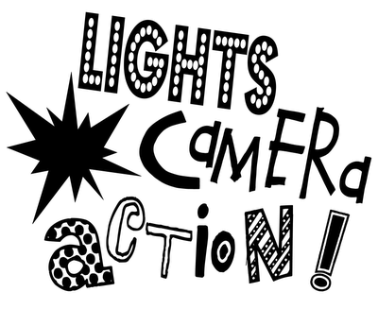
Curriculum area here
References here
- Activity ideas here
- And here
Curriculum area here
References here
- Activity ideas here
- And here
- Etc.
Curriculum area here
References here
- Activity ideas here
- And here
Curriculum area here
References here
- Activity ideas here
- And here
Curriculum area here
References here
- Activity ideas here
- And here
Curriculum area here
References here
- Activity ideas here
- And here

