OUTPUT
Text here
OUTPUT
Text here

Completed by: ______________________ Date: __________
PLANNING FOR EVALUATION
Text here
PLANNING FOR SUSTAINING IMPACT
Text here
PLANNING THE LEARNING AWAY PROGRAMME
Text here
IDENITIFIED LEARNING PROBLEM OR OPPORTUNITY
Text here
OUTCOME
Text here
OUTCOME
Text here
OUTCOME
Text here
OUTCOME
Text here
OUTCOME
Text here
ASSUMPTION
INPUT/OUTPUT
Text here
ASSUMPTION
OUTPUT/OUTCOME
Text here

LONG-TERM AIM/S
Text here
Learning Away Theory of Change Planner

Name of residential programme: ___________________________________

Specific residential (if relevant): ____________________________________
INPUTS
TASKS
Text here
RELATIONSHIPS
Text here
ENVIRONMENT
Text here
LEARNING PROCESS
Text here
INFORMAL TIME
Text here
LENGTH OF STAY
Text here
INPUTS
OTHER
Text here
OUTPUT
Text here
OUTPUT
Text here

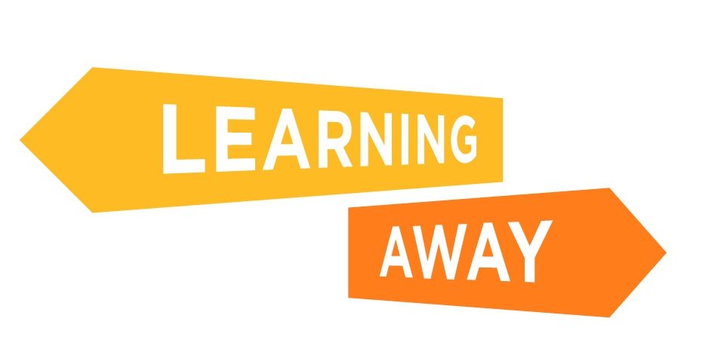
This planning template was developed for Learning Away by Julie Temperley, Director of Temperley Research Ltd
You are free to share for non-commercial purposes, but please signpost: http://www.learningaway.org.uk


You are free to share for non-commercial purposes, but please signpost: http://www.learningaway.org.uk

