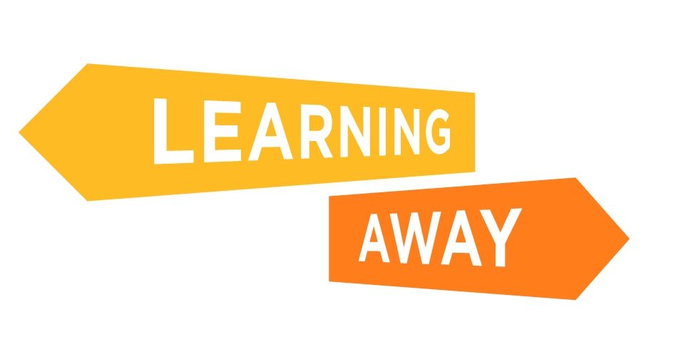

The Learning Away schools have developed a series of themed resource packs to help other schools plan and deliver Brilliant Residentials.

Find out more at: http://www.learningaway.org.uk/

EARLY YEARS RESIDENTIALS: ACTIVITY – RISKS AND CHALLENGES

Consider the risks and challenges in the list below and identify actions you could take to reduce and manage these risks so that the residential can take place safely and effectively. The boxes on the right will expand to fit your text.

Risks and challenges | Actions to remove, minimise and manage these risks
Planning and preparation time a burden on staff
Cost to families
Cost to school / setting
Low awareness of the benefits amongst staff
Costly training for teachers
Transport to and from residential
Inclusion – meeting the needs of individual children
Staffing levels
Burden of responsibility for staff
Bureaucracy and form filling
Asking too much of staff
Impacting on staff home life
Parental anxieties about letting child go on trip
Identifying a suitable location for a residential experience
Managing the expectations of parents and children
Child who is unhappy, nervous, missing home
Missing child
Managing contact between parents and children
Fears about health and safety and legal action

