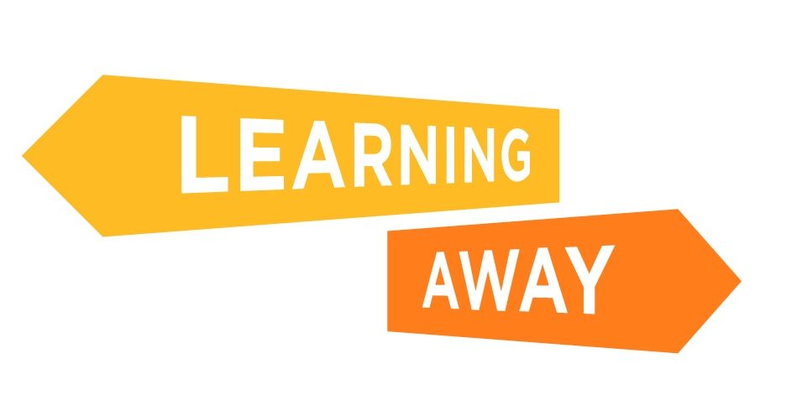

The Learning Away schools have developed a series of themed resource packs to help other schools plan and deliver Brilliant Residentials.

Find out more at: http://www.learningaway.org.uk/

EARLY YEARS RESIDENTIALS: ACTIVITY – ACTIONS AND PRIORITIES

Identify your actions and priorities. What do you need to do next to support the implementation of residential experiences in your school? The boxes will expand to fit your text.

Next week I need to…
Next term I need to…
Next academic year I need to…

