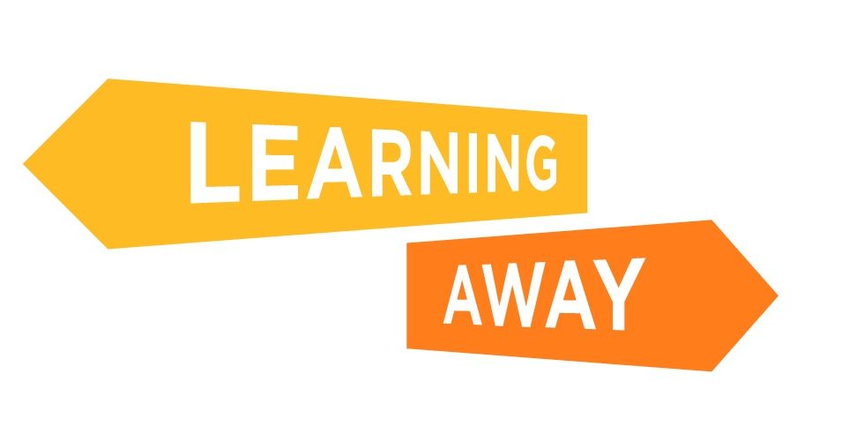

The Learning Away schools have developed a series of themed resource packs to help other schools plan and deliver Brilliant Residentials.

Find out more at: http://www.learningaway.org.uk/

GETTING READY: PACKING A SUITCASE

LEARNING INTENTION:
- What do we need to take with us on the Residential?
- How do we make sure we bring it all back again?

Travelling to the residential: | Sleeping in a different bed:
Hoodie, green (Ben Sherman) | Pillowcase, white  Cuddly
Personal hygiene: | The time of year:
Towel (Lion King)  Toothbrush, white | Warm clothes, hat, gloves
Adventure activities: | Indoor / outdoor clothing:
Map case, green | Waterproof jacket and trousers  Trainers, silver
Evenings and last night disco: | Travelling back home:
Jeans, blue | Hoodie, green (Ben Sherman)

Unpack the case, neatly. What would you do with your gear and clothes if:

- You’re just back from an activity and your things are wet: put in the drying room

- You’re late back from an activity and your dinner is ready: throw things in room

- It’s 5 minutes until the bus leaves to go home: better get the suitcase packed!

Back home, check your suitcase. Do you have everything?
In future, how can we make sure we take the right things and bring them all home?

