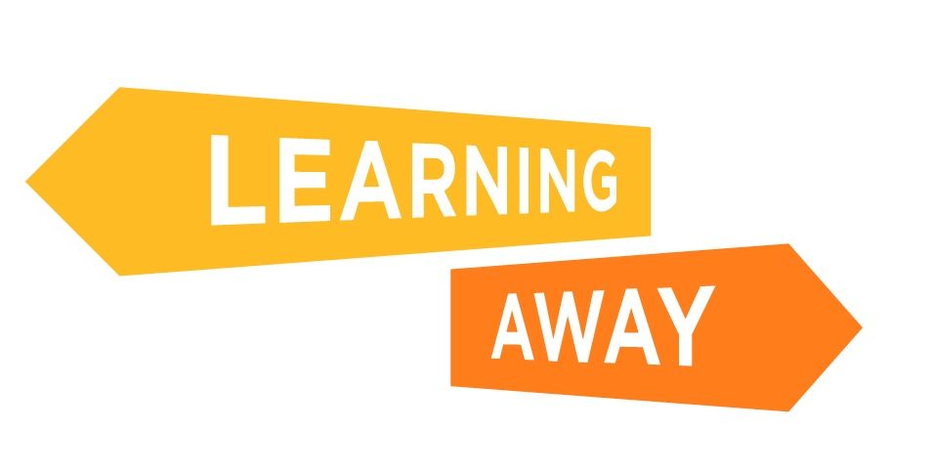
The Learning Away schools have developed a series of themed resource packs to help other schools plan and deliver Brilliant Residentials.
Find out more at: http://www.learningaway.org.uk/

INTEGRATED RESIDENTIAL PLANNER

TEMPLATE

RESIDENTIAL:
ACTIVITIES / LEARNING EXPERIENCES |  | FORMATIVE ASSESSMENT OPPORTUNITIES
 |  | EVIDENCE TO BE GATHERED
 |  | NEXT STEPS
CONTRIBUTION TO THE FOUR CAPACITIES* (PLEASE HIGHLIGHT KEY AREAS) |  | BREADTH – how will learning connect? | CHALLENGE- how will level of challenge be increased?
SUCCESSFUL LEARNER | CONFIDENT INDIVIDUALS with: | BREADTH – how will learning connect? | CHALLENGE- how will level of challenge be increased?
RESPONSIBLE CITIZENS | EFFECTIVE CONTRIBUTORS | APPLICATION – how will skills be applied in different contexts? | INCLUSIVE APPROACHES

* The ‘Four Capacities’ of the Scottish Curriculum for Excellence are outlined here. They are similar to the [English / Welsh] Every Child Matters outcomes. When using this template you could insert your school or curriculum’s overarching objectives, if the Four Capacities are not applicable.
INTEGRATED RESIDENTIAL PLANNER

SAMPLE – COMPLETED BY STAFF AT SANDERSON HIGH SCHOOL

RESIDENTIAL: | Learning Away: Keswick – Year Group: S1
ACTIVITIES / LEARNING EXPERIENCES  - What is 'Learning Away'?  - Where do S2/3 go on their residentials?  - Where is Keswick?  - Activities on location, mapping  - What activities do S2/3 do?  - Who looks after us?  - What things do we need to be able to do by ourselves? Independent living skills  - What do we need to take with us? Clothes (weather), footwear, hygiene and personal care  - Where do we sleep? Issues, fears?  - What else do we want to ask S2/3? |  |  | FORMATIVE ASSESSMENT OPPORTUNITIES  - Mind maps at start of topic - what do we know about Keswick? What do we need for a holiday / residential trip? What do we want to learn?  - Mind maps at end to compare - what do we know now?  - Pupils make questionnaire for S2/3 to complete following residential - 'What we need to know - can you help us?'
EVIDENCE TO BE GATHERED
- Photographs of pupil discussions
- Mind maps
- Questionnaires
- Pupil evaluations - 'what I learned'
NEXT STEPS
- Share questionnaires with S2/3
- Arrange S1-3 sharing or invite some S2/3 pupils to tell us about their Keswick trip
CONTRIBUTION TO THE FOUR CAPACITIES (PLEASE HIGHLIGHT KEY AREAS) |  |  | BREADTH – how will learning connect?  - Link to PSE life skills, literacy – use questionnaire | CHALLENGE- how will level of challenge be increased?  - Some pupils to present research / findings / experiences to others  - Some pupils to research and support peers through sharing information
SUCCESSFUL LEARNER  - Enthusiasm and motivation for learning  - Think creatively and independently  - Learn as part of a group |  | CONFIDENT INDIVIDUALS with:  - Self respect / secure values and beliefs / ambition  - Able to: be self aware / achieve success in different areas of activity
RESPONSIBLE CITIZENS  - Respect for others  - Develop informed, ethical views of complex issues |  | EFFECTIVE CONTRIBUTORS  - Enterprising attitudes / resilience / self reliance  - Communicate in different ways and different settings | APPLICATION – how will skills be applied in different contexts?  - Hygiene at school, home  - Independent skills - what do we do at home, school | INCLUSIVE APPROACHES  - Makaton  - BoardMaker  - Peer support

