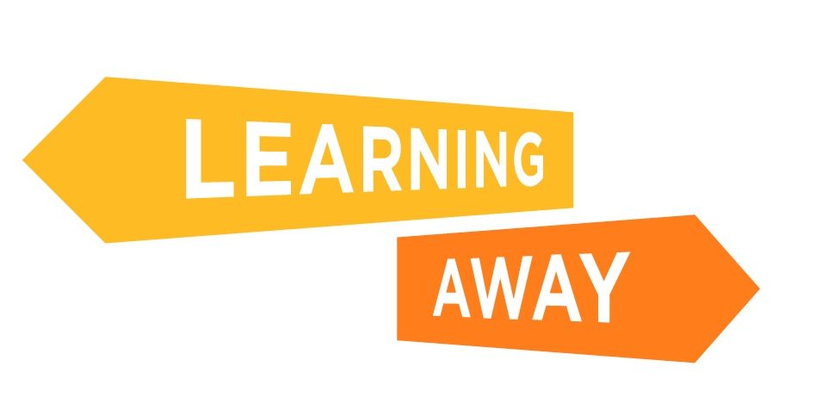
The Learning Away schools have developed a series of themed resource packs to help other schools plan and deliver brilliant residentials. Find out more at: http://www.learningaway.org.uk/

Feel free to adapt this template to suit your needs.

RESIDENTIAL EVALUATION

Name: Year group: Date: Residential venue:

Tasks being evaluated: Preparation for a residential experience; Participating in a residential experience.

Tell the story in pictures or words
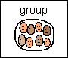  Write about, or pick one picture that shows working with others. |   Write about, or pick at least one picture that shows something you are proud of. | 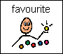  Pick one picture that shows your favourite activity or write about it.
Look at the pictures you have chosen. What did you do that you are proud of?

- I can now:

- I have:

